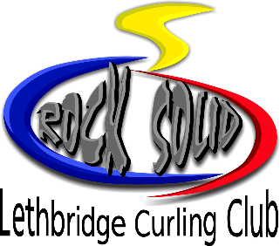
Little Rockers 8 – 10 years
Juniors 11 years & up

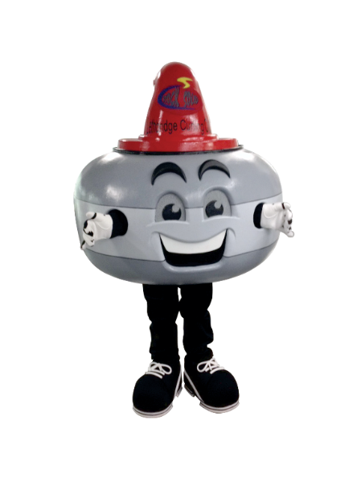
2017 2018
Oct 25 Jan 10
Nov 1 Jan 17
Nov 8 Jan 24
Nov 22 Feb 7
Nov 29 Feb 14
Dec 6 Feb 21
Dec 13 Feb 28
Mar 7
Mar 14
Mar 21

- Little Rockers and Juniors curl 16 weeks in the 2017/2018 season.
- Curl Wednesdays 4:15 pm
- Little Rockers 8 – 10 years: $130
- Juniors 11 years & up: $150
- Price includes GST

Register by calling 403-327-1213, at the Club Pro Shop or www.LethbridgeCurlingclub.com
Please note: the Lethbridge Curling Club has adopted Canada Curling’s new helmet policy effective August 1, 2017.
POLICY
It is the policy of the Lethbridge Curling Club that any participant, UNDER THE AGE OF 12, curling at the Lethbridge Curling club, either in a club league, clinic or any rental group to wear a helmet at all times while on the ice.
PREAMBLE
This is an important move that puts The Lethbridge Curling Club in a leadership position in terms of making sure our young and beginning curlers are playing the sport with safety in mind.
GUIDELINES
- The following CSA Certified Impact resistant helmets are allowed. Hockey, Bicycle, Alpine Ski or Snowboarding, Skateboarding and Curling Helmets. Also acceptable are purpose designed impact resistant Curling Hats, Toques and Headbands.

